Chapter 8 homework

- Complete exercises 8.38 (for part a, use examine.mod.multiple.R; construct a scatter plot of the data with the second-order sample model plotted upon it and use this to help justify your results in c.), 8.40, and 8.41
- Examine tests from 2012
- Reproduce all examples in the notes

Partial answers:

8.38
Answer key
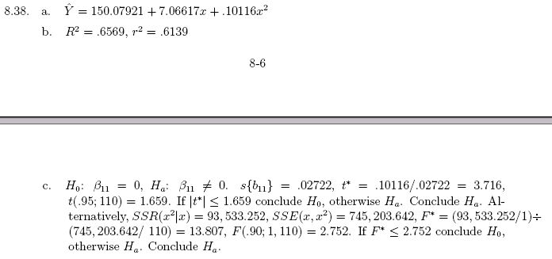
Additional results

Without doing the mean adjustment to X:

> lm(formula = nurses ~ facilities + I(facilities^2), data = senic)

Call:
lm(formula = nurses ~ facilities + I(facilities^2), data = senic)

Coefficients:
(Intercept) facilities I(facilities^2)
33.5482 -1.6661 0.1012

Plots from examine.mod.multiple().
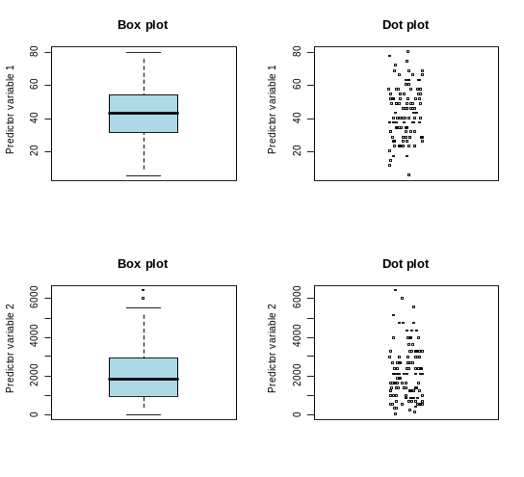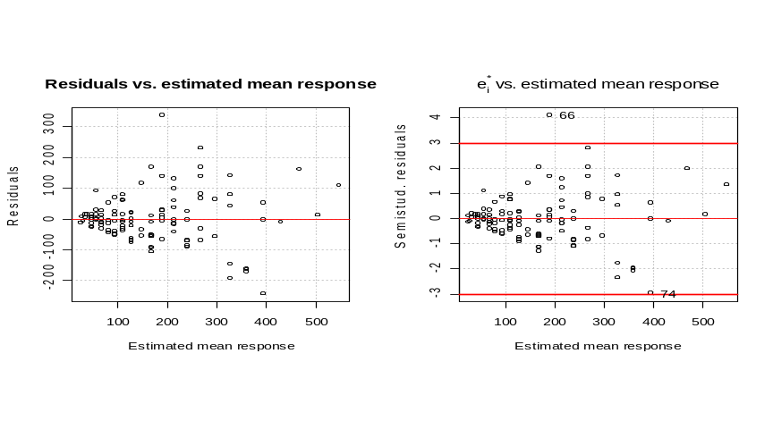

Notice how the two plots below have the same shape. This is because X is used on the x-axis for the left plot and X² is used on the x-axis for the right plot. Again, only one plot of residual vs. X would be needed.
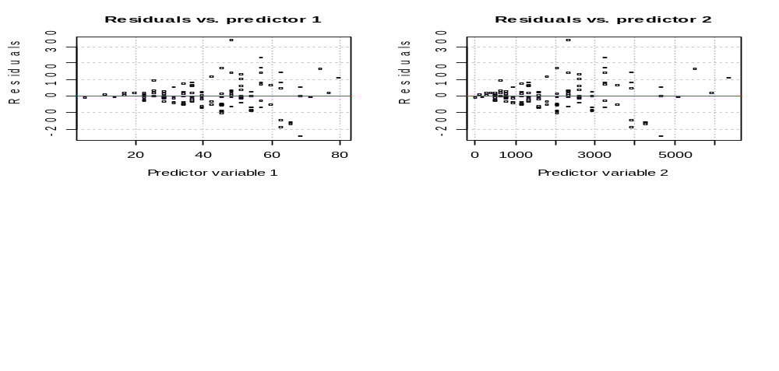

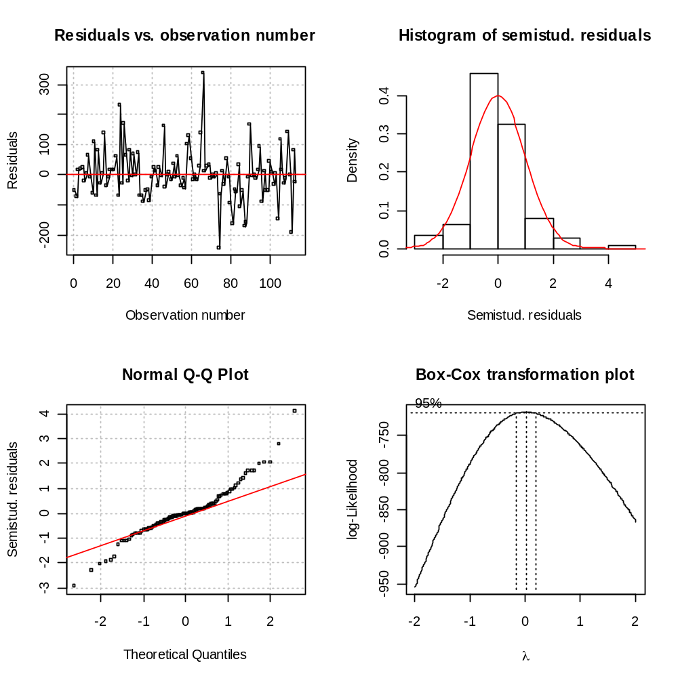
The first action that I would take to fix the model would be to try a log() transformation as suggested by the Box-Cox transformation plot above. I did this (code and output excluded) and it helped solve the problems with the model!

For the scatter plot with the estimated model plotted upon it (just using the original response variable of nurses, not log(nurses)), below is my R code and output. Notice how the predict() function can be used to make predictions and only facilities needs to be given, not facilities². Overall, this should be done with log(nurses) since this transformation helps to solve the problems of the model. Since I did not specifically ask you to do this in the homework, I have only shown here how to do it with just nurses.

> #Example
> predict(object = mod.fit, newdata = data.frame(facilities = 20))
[1] 40.69105

> par(mfrow = c(1,1))
> plot(x = senic$facilities, y = senic$nurses, xlab = "Facilities", ylab =
"Nurses", main = "Nurses vs. facilities")
> curve(expr = predict(object = mod.fit, newdata = data.frame(facilities = x)),
lty = 1, col = "red", add = TRUE)

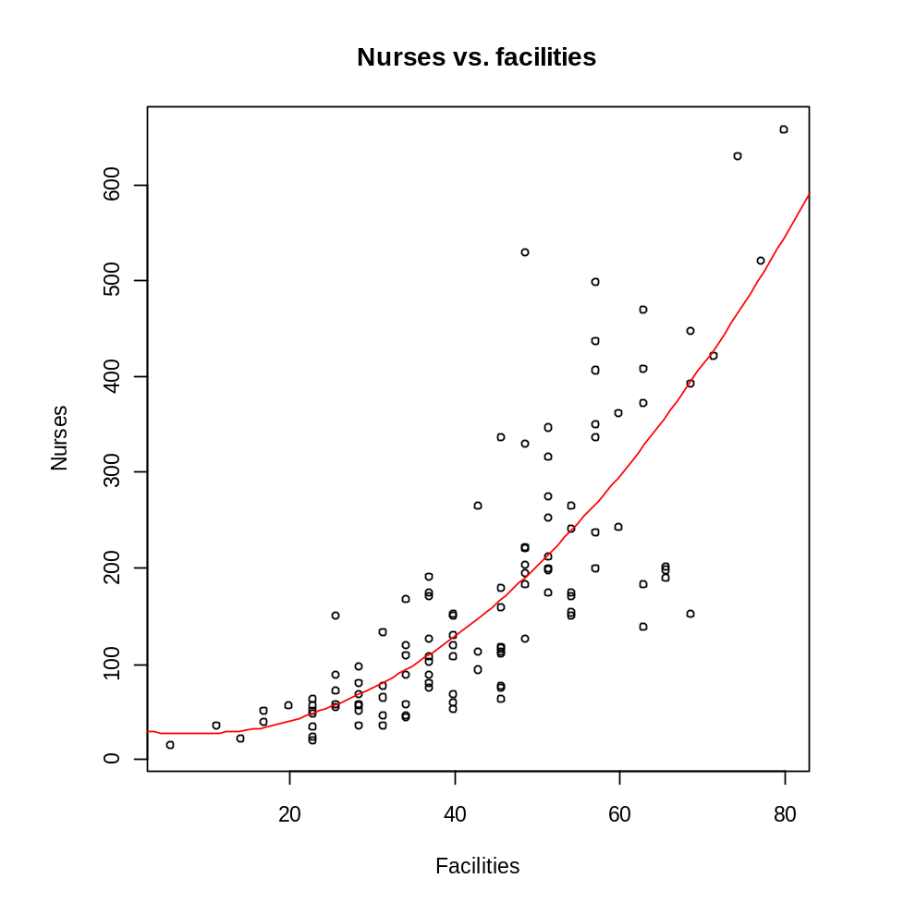

8.40
Answer key:
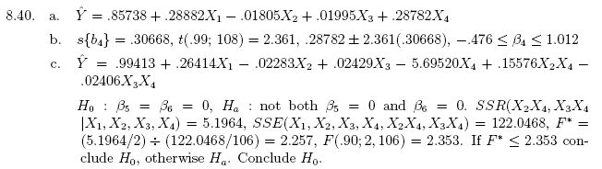
Note that the lower bound for the C.I. in b. is incorrect.

School is coded as 1 = Yes and 2 = No in the data set. By default, R will interpret school as a quantitative variable. This can be changed by using the factor() function for school. Since 1 comes before 2, R will use the coding of No = 1 and Yes = 0. You can use this coding instead of that asked for in KNN (Yes = 1 and No = 0) as long as you change your interpretation accordingly. If you really wanted Yes = 1 and No = 0, use factor(-school) in your formula statement of lm().

To include an interaction term for school and age, use factor(school):age in the formula statement.

Below is part of my R code and output.

> mod.fit<-lm(formula = infection ~ stay + age + xray + factor(school), data =
senic)
> summary(mod.fit)

Call:
lm(formula = infection ~ stay + age + xray + factor(school),
data = senic)

Residuals:
Min 1Q Median 3Q Max
-2.746693 -0.766465 -0.002831 0.772670 2.597035

Coefficients:
Estimate Std. Error t value Pr(>|t|)
(Intercept) 1.14520 1.32437 0.865 0.38911
stay 0.28882 0.06291 4.591 1.20e-05 ***
age -0.01805 0.02411 -0.749 0.45569
xray 0.01995 0.00577 3.458 0.00078 ***
factor(school)2 -0.28782 0.30668 -0.938 0.35009
---
Signif. codes: 0 '***' 0.001 '**' 0.01 '*' 0.05 '.' 0.1 ' ' 1

Residual standard error: 1.085 on 108 degrees of freedom
Multiple R-Squared: 0.3681, Adjusted R-squared: 0.3447
F-statistic: 15.73 on 4 and 108 DF, p-value: 3.574e-10

> contrasts(factor(senic$school))
2
1 0
2 1

> confint(object = mod.fit, level = 0.98)
1 % 99 %
(Intercept) -1.982125100 4.27251940
stay 0.140268153 0.43736659
age -0.074992776 0.03888795
xray 0.006325715 0.03357586
factor(school)2 -1.012011565 0.43637593

8.41
Answer key
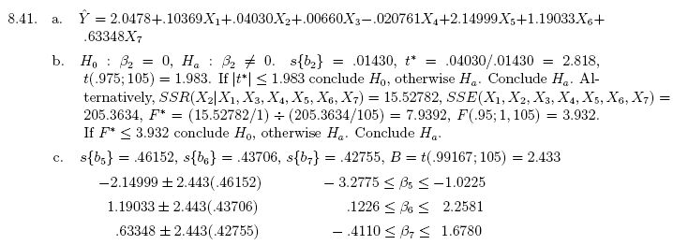

Region is coded as 1 = NE, 2 = NC, 3 = S, 4 = W in the data set. You can use R’s default coding of the indicator variables instead of what is given in KNN. Below is part of my R code and output from fitting the model in a. Of course, my model will be different from the answer key since R’s default coding of the indicator variables is different from KNN’s coding. All inferences will be the same though.

> mod.fit<-lm(formula = stay ~ age + culture + census + facilities +
factor(region), data = senic)
> summary(mod.fit)

Call:
lm(formula = stay ~ age + culture + census + facilities + factor(region),
data = senic)

Residuals:
Min 1Q Median 3Q Max
-2.793825 -0.730445 0.003671 0.538789 7.723120

Coefficients:
Estimate Std. Error t value Pr(>|t|)
(Intercept) 4.197818 1.878025 2.235 0.027519 *
age 0.103691 0.031459 3.296 0.001338 **
culture 0.040302 0.014303 2.818 0.005781 **
census 0.006600 0.001404 4.700 7.92e-06 ***
facilities -0.020761 0.014369 -1.445 0.151477
factor(region)2 -0.959655 0.381722 -2.514 0.013454 *
factor(region)3 -1.516510 0.380092 -3.990 0.000123 ***
factor(region)4 -2.149988 0.461517 -4.659 9.37e-06 ***
---
Signif. codes: 0 '***' 0.001 '**' 0.01 '*' 0.05 '.' 0.1 ' ' 1

Residual standard error: 1.399 on 105 degrees of freedom
Multiple R-Squared: 0.4981, Adjusted R-squared: 0.4647
F-statistic: 14.89 on 7 and 105 DF, p-value: 2.283e-13

For part c., this is where KNN’s coding of the indicator variables is helpful because C.I.s for β_{NE}, β_{NC}, and β_{S} would need to be found only (β_{W} = 0 for their coding). The coding that I used makes it a little more difficult. To compare NE to W, we need to find a C.I. for β_{NC} – β_{W} where these β’s are for my model. The point estimate for β_{NC} – β_{W} is b_{NC} – b_{W} = b₅ – b₇ =
-1.888360864 – (-3.272830603) = 1.190333. Note that Var(b_{NC} – b_{W}) = Var(b_{NC}) + Var(b_{W}) – 2Cov(b_{NC}, b_{W}). Below is my R code and output. Pay special attention that my C.I.s match up with KNN’s C.I.s in the answer key. If you have had a formal class in ANOVA methods, you should remember that contrasts like the β_{NC} – β_{W} here will be the same despite different estimation restrictions for the treatment parameters (indicator variables coded differently here in our case).

> confint(object = mod.fit, level = 1-0.05/3)
0.833 % 99.167 %
(Intercept) -0.371302769 8.76693975
age 0.027152569 0.18022992
culture 0.005502804 0.07510167
census 0.003183901 0.01001671
facilities -0.055720356 0.01419794
factor(region)2 -1.888360864 -0.03095004
factor(region)3 -2.441251550 -0.59176906
factor(region)4 -3.272830603 -1.02714609

> #C.I. for beta5 - beta7, b5 is 6th and b7 is 8th position in
mod.fit$coefficients
> b5.b7<-mod.fit$coefficients[6] - mod.fit$coefficients[8]
> var.b5.b7<-vcov(mod.fit)[6,6] + vcov(mod.fit)[8,8] - 2*vcov(mod.fit)[6,8]
> b5.b7+qt(p = c(0.05/(2*3), 1-0.05/(2*3)), df = mod.fit$df.residual)*
sqrt(var.b5.b7)
[1] 0.1269983 2.2536675

> #C.I. for beta6 - beta7
> b6.b7<-mod.fit$coefficients[7] - mod.fit$coefficients[8]
> var.b6.b7<-vcov(mod.fit)[7,7] + vcov(mod.fit)[8,8] - 2*vcov(mod.fit)[7,8]
> b6.b7+qt(p = c(0.05/(2*3), 1-0.05/(2*3)), df = mod.fit$df.residual) *
sqrt(var.b6.b7)
[1] -0.4067357 1.6736918

> #C.I. for beta7 - also could use confint() for this one
> mod.fit$coefficients[8]+qt(p = c(0.05/(2*3), 1-0.05/(2*3)), df =
mod.fit$df.residual) * sqrt(vcov(mod.fit)[8,8])
[1] -3.272831 -1.027146

> #Notice that KNN uses 2.433 for their quantile which is not the 1-0.05/6
quantile from the t-distribution.
> # This is the cause for the small differences between my answers and their
answers.
> pt(q = 2.433, df = 105)
[1] 0.991668

Overall, there are differences between W and NC because 0 is not in the interval comparing the two. Also, there are differences between W and NE because 0 is not in the interval comparing the two.

